# CS 255 System Design Document Template

This template lays out all the different sections that you need to complete for Project Two. Each section has guidance to prompt your thinking. You will need to continually reference the interview transcript as you work to make sure that you are addressing your client’s needs. There is no required length for the final document. Instead the goal is to complete each section based on what your client’s needs are. Remove this note when you are finished, and replace all bracketed text with the relevant information.

## UML Diagrams

### UML Use Case Diagram

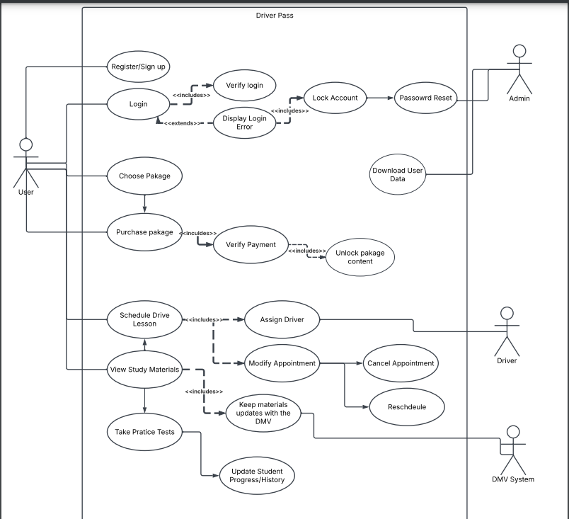

### UML Activity Diagrams

Login Diagram

Select Package options and payment diagram

### UML Sequence Diagram

### UML Class Diagram

## Technical Requirements

Some technical requirements based on these diagrams are

* All users can login and have access to the password reset system
* More than 3 wrong attempts locks the account
* Admins can download user data
* Drivers can put in their availability
* Clients can book drive appointments based on driver availability
* Once paid for the different learning package options will unlock for the specific user